Mahdi Chowdhury
Professor Lisa Rogal
FIQWS 10108 Individual & Society
Self-Assessment
My writing has always been good. When I was in my home country, I never faced difficulties on writing. Now I am in a different country with a different language. So When I took this course, I was little bit worried about how it was going to be or what type of problem I could face. But this course helped me to realize that through practice and revision anybody can write something at college level. So, During the semester we wrote a summary and response essay, exploratory essay, bibliography and a research critical analysis paper. Writing these papers taught me how to express myself through some systematic way of writing. In this course, I demonstrated few courses learning outcomes.
The first learning outcome was Explore and analyze in their own and others’ writing a variety of genres and rhetorical situations. I demonstrated this for our first writing assignment when we wrote a Summary and response essay. The main objective was to summarize and response it with 2 or 3 rhetorical situations. I explored the message behind the article that we used to summarize by looking at things like purpose and audience and tried to analyze it. Below I put this excerpt from reflection.
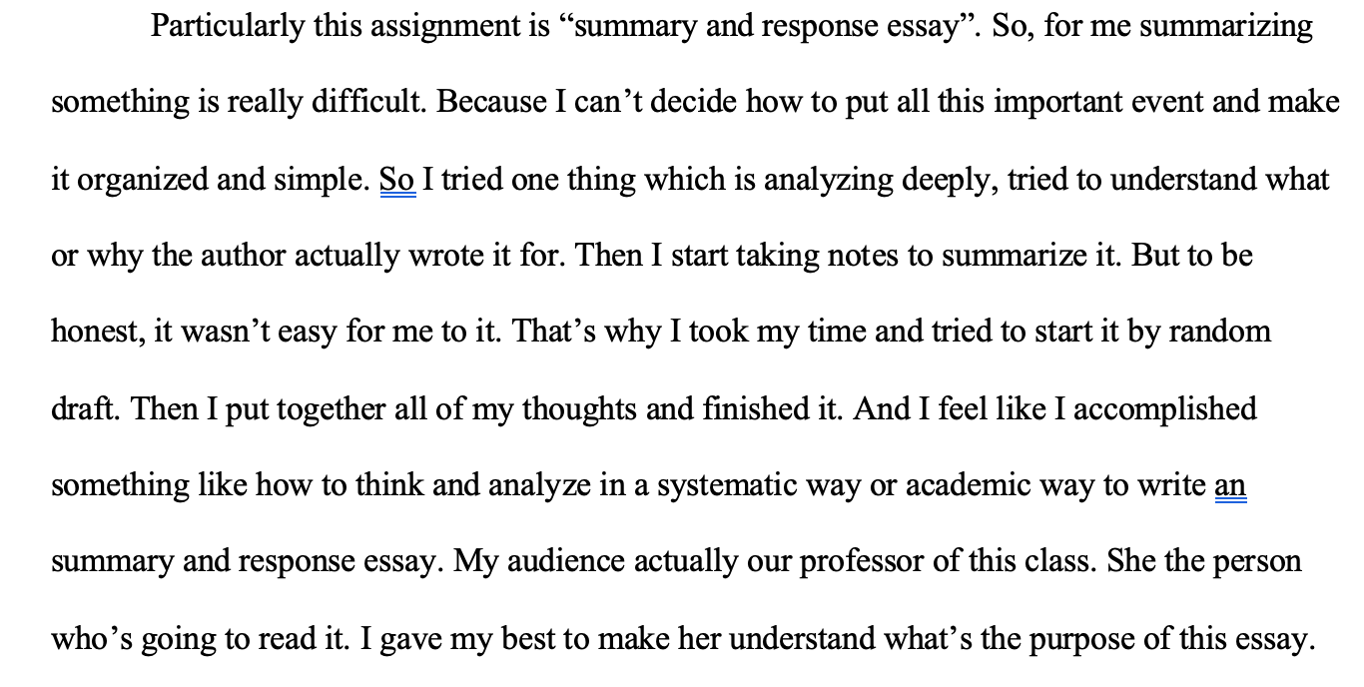

The second learning outcome states that Develop strategies for reading, drafting, revising, and editing. Through the course of writing essays this semester, I followed several process in order to write the essays. For example, for my exploratory essay or critical analysis essay, I had to read the texts I was using in my paper. When I am done reading, I had to map out what my arguments were, what my claims were. After I did my first draft. When I finished drafting, I had to read over my work and fix errors. With each essay, I improved little bit on this process. Inserted below is from my draft of my critical analysis essay. 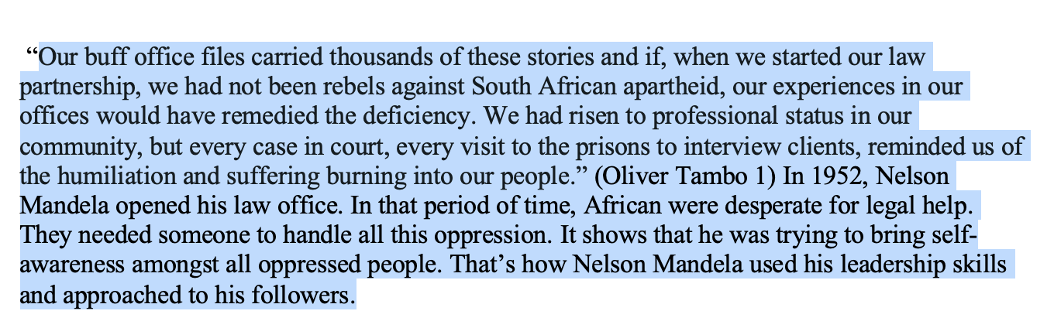
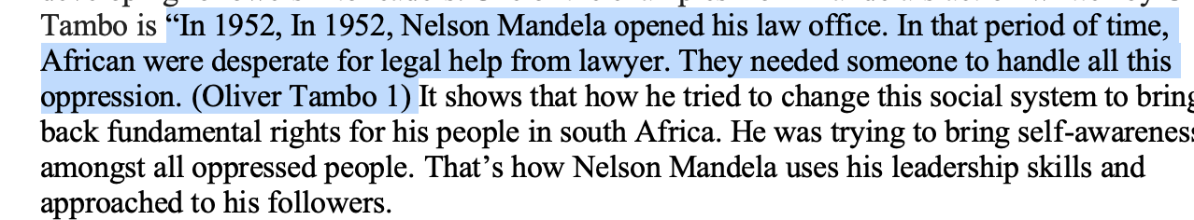
The third learning outcome states that Understand and use print and digital technologies to address a range of audiences. Through the use of Blackboard in this composition class, I was able to share my journal response. My audience here was my classmates. Now I have this portfolio with the work I have done for this class. Inserted is a screenshot of Journal that I wrote:
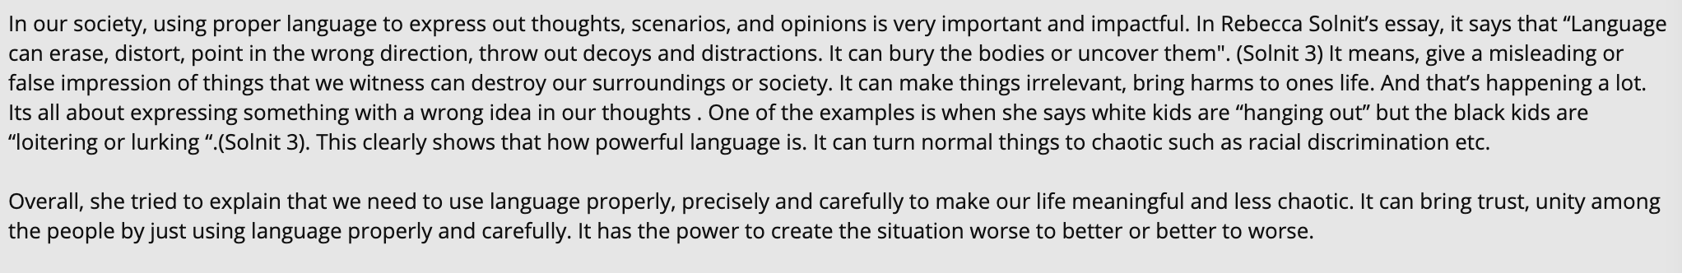

The fourth learning outcome states: Recognize and practice key rhetorical terms and strategies when engaged in writing situations. This learning outcome was demonstrated in the writing of my Summary and Response essay. To fully understand the meaning of a text in general, I had to consider the audience, genre, media/design, stance, and purpose. I addressed some of these rhetorical terms where I explained what their importance were. Inserted below is an excerpt from my Summary and Response essay where I determined the purpose and audience of the essay that we read.

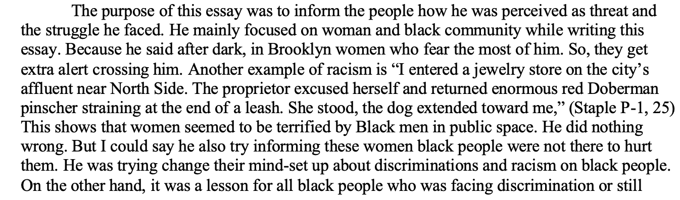
.
I engaged in the collaborative and social aspects of writing processes. In class, we did workshop on essays which I think best part of the class. This is helpful because you get to see lot of others writing at a time and compare it to yourself. While doing this, my peers addressed some silly mistakes that I would never able find it. Discussing with peers is better because lot of eyes on my easy helped me to fix lot of problems easily.
Another course learning outcome that I demonstrated was to locate research sources (including academic journal articles, magazine and newspaper articles) in the library’s databases or archives and on the Internet and evaluate them for credibility, accuracy, timeliness, and bias. I achieved this course learning outcome by using CCNY databases for research on my exploratory essay and research critical analysis. This helped me find the sources that are more reliable and trustworthy than the sources found on internet. These sources played a big role in these two papers since it required a lot of research.
Furthermore, the learning outcome was composing texts that integrate the student’s stance and language with appropriate sources, using strategies such as summary, critical analysis, interpretation, synthesis, and argumentation. In our exploratory and critical research papers, we had to make an argument and prove that argument through evidence and analyzing. I analyzed the argument and evidence at my level best. All my claims supported my argument in my thesis.

I practiced systematic applications of citation conventions. This was possible through my exploratory essay and research critical analysis. I demonstrated this by doing annotated bibliographies. When we write something like research paper, we use lot of outside resources. So, for that we had to use MLA format citation. For this reason, annotated bibliographies helped me to evaluate the source, how it goes with my essay and citing it properly. Also, through the class workshop, my peers gave me feedback to fix my citation and it helped me to do it properly in the paper.
Overall, during the semester we wrote a Summary and response essay, exploratory essay, and a research critical analysis paper. All of these papers helped me to improve as a writer. Though I have always been a good writer since back home. Now I am able to write papers at a entry college level In my second language which is English.

